

Champions of Character

Corporate Sponsorship Opportunities

**Take a Stand with Georgia’s Educators, Business Leaders, and Parents**

Join a powerful coalition dedicated to impacting teens and communities through personal essays. The Georgia Laws of Life Essay Contest is not just an educational initiative; it’s a return to the basics of character, mental health, positive self-image, and empowerment for self-worth. This is your chance to play a crucial role in shaping the future of Georgia's youth while gaining significant exposure and goodwill for your business.

**Our Story: Changing Lives One Essay at a Time**

The Georgia Laws of Life Essay Contest is a transformative character education program that reaches high school students across the entire state. Over 60 schools participate each year, engaging more than 40,000 students who write deeply personal and reflective essays about their core values. This cost-free program offers a unique and invaluable opportunity for students to develop ethical literacy and strong character, guided by their teachers and supported by their communities.

As students reflect on the values and principles that matter most to them, something magical happens. Through the power of the pen, students begin to see themselves and others with a new perspective. Frequently, the contest nudges students not just to articulate their ideals, but to live out their “best versions” of themselves – lives full of courage, compassion, and gratitude.

The contest culminates in awarding $20,000 in cash prizes to students and teachers, celebrating their stories and reflections. Your sponsorship will enable us to expand this impactful program, reaching even more students and fostering the next generation of ethical leaders. Plus, thanks to the generous support of the Templeton Foundation, every dollar you donate will be matched dollar-for-dollar until October 15, doubling your impact.

**The Impact**

* **Statewide Reach**: More than 40,000 students participate annually at over 60 schools and 60 partnering Rotary Clubs.
* **Ethical Literacy**: Encouraging students to reflect on their values and articulate their principles, fostering personal growth and community engagement.
* **Significant Awards and Recognition**: The contest presents $20,000 in cash awards to students and teachers.
* **Community Building**: Promotes core values like courage, compassion, and gratitude, helping students become better citizens with life skills needed to meet the challenges and responsibilities of adulthood.
* **Matching Dollars Now Available**: The Templeton Foundation has supported this mission for several years and is now issuing a Dollar-for-Dollar Match.

**Sponsorship Packages**

**All contributions will be matched dollar-for-dollar by the Templeton Foundation until October 15.**

| **Title Sponsor - $10,000 (Only 1 Spot Available)** | **Presenting Sponsor - $5,000 (Only 2 Spots Available)** | **Supporting Sponsor - $2,500 (Only 4 Spots Available)** |
| --- | --- | --- |
| * Top-tier logo placement on the website and all promotional materials. * Prominent recognition at all program events, * Opportunity for a company representative to give a speech at program Founders Celebration event. * Includes 10 tickets to the Essay Contest Founders Celebration event * Exclusive feature in newsletter communications to partner schools and Rotary Clubs. * Logo inclusion in social media and email communications. * Joint video announcement with the Executive Director, showcasing the business’s support. * Direct engagement with Georgia Rotary Clubs and their members. * Logo inclusion on all announcements awarded to students. | * High-level logo placement on the website and promotional materials. * Recognition at all program events. * Includes 8 tickets to the Essay Contest Founders Celebration event * Mention in newsletter communications to partner schools and Rotary Clubs. * Joint video announcement with the Executive Director, showcasing the business’s support. * Direct engagement with Georgia Rotary Clubs and their members. * Logo inclusion in social media and email communications. * Recognition inclusion on all announcements awarded to students. | * Logo placement on the website. * Recognition at program events. * Mention in newsletters and social media posts. * Includes 4 tickets to the Essay Contest event. * Logo inclusion in social media and email communications. * Direct engagement with Georgia Rotary Clubs and their members. * Inclusion on all announcements awarded to students. |

**Join us in making a difference today!**

**Other sponsorship levels are available. Download and complete a** [**SPONSORSHIP FORM**](https://drive.google.com/file/d/13XJxeuWu-zKSd3bJFrP9_wdVfxyGcGfO/view?usp=drive_link)**.** 

**What Students are Saying:**

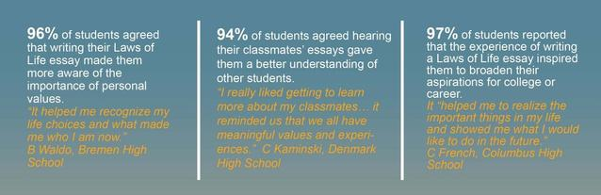

**Why Partner with Us?**

By partnering with us, your business will align with other reputable organizations and influential leaders who support this impactful initiative. This creates a powerful network of businesses and community leaders dedicated to fostering strong character and ethical behavior in the next generation.

We offer valuable benefits, including exclusive insights, networking opportunities, and heartfelt thank yous from the students. Your business will gain significant exposure through our website, promotional materials, social media, and event recognition across Georgia. Personal stories and testimonials from students who have been transformed by the program will show the real impact of your support, creating a powerful emotional connection.

**What Teachers are Saying:**

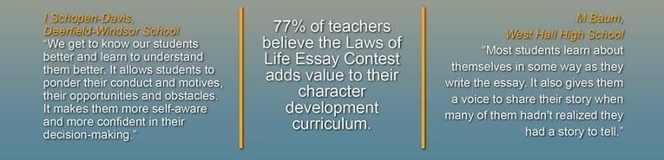

By partnering with the Georgia Laws of Life Essay Contest, your business will not only support the ethical development of Georgia's youth but will also gain access to a broad network of influential business and community leaders across the state. This is a unique opportunity to enhance your brand's visibility and reputation while making a profound impact on the community.